Project Documentation

AI FAQ ASSISTANT
- INTRODUCTION
Project Title : AI FAQ ASSISTANT
Team ID : SWTID-2026-6260
Team Leader:
DIVYA RANI JENA B & divyadjloyal@gmail.com
Tam Members:
ARIA SRI A & ariasriamudhan@gmail.com
KRISHNA PRIYA YN & krishnapriyayn@gmail.com
LAKSHITHA T & lakshitha.thandayuthapani2006@gmail.com
- PROJECT OVERFLOW

Purpose
This project creates an AI FAQ Assistant that helps users get quick and accurate answers to frequently asked questions. It provides users with an interactive interface where they can enter their questions and receive relevant answers from the available FAQ knowledge base.
Features
- AI-powered question and answer system Frequently Asked Questions (FAQ) management User-friendly chat interface
- Search and retrieve FAQ answers Category-based FAQ organization
- Add, update and delete FAQ information
- Architecture
Frontend: HTML, CSS and JavaScript Backend: Node.js
Database: MongoDB (stores questions, answers and categories)
AI/FAQ Processing: Processes user questions and retrieves the most relevant FAQ answer.

- SETUP INSTRUCTIONS
Prerequisites
Node.js
MongoDB
Visual Studio Code
Git
Web Browser
Installation Steps
#Clone repository
Git clone <repo-link>
# Install dependencies
cd server
npm install
# Run back
npm start
# Open frontend
Open the frontend project in Visual Studio Code

- FOLDER STRUCTURE
AI FAQ ASSISTANT
│
├── frontend/
│ ├── index.html
│ ├── style.css
│ └── script.js
│
├── backend/
│ ├── routes/
│ ├── models/
│ ├── controllers/
│ └── server.js
│
└── database/
└── FAQ DATA

- RUNNING THE APPLICATION

Back:
- cd backend
- npm start
Front:
- Open index.html in the web browser
- Access:FAQ Assistant available at:http://localhost:3000

7.API DOCUMENTATION :
FAQ:
GET /api/faqs – Fetch all FAQs GET /api/faqs/:id – Get FAQ details POST /api/faqs – Add a new FAQ PUT /api/faqs/:id – Update FAQ DELETE /api/faqs/:id – Delete FAQ User:
POST /api/user/register – Register new user POST /api/user/login – Login use

8.AUTHENTICATION:
User authentication can be implemented for secure access to the FAQ management system. User registration
User login
Protected FAQ management routes

9.USER INTERFACE(VR SCREENS):
Home Page
AI FAQ Chat Interface FAQ Search Screen FAQ Category Screen
Admin FAQ Management Screen Login / Registration Screen
10.OUTPUT SSCREENSHOT:
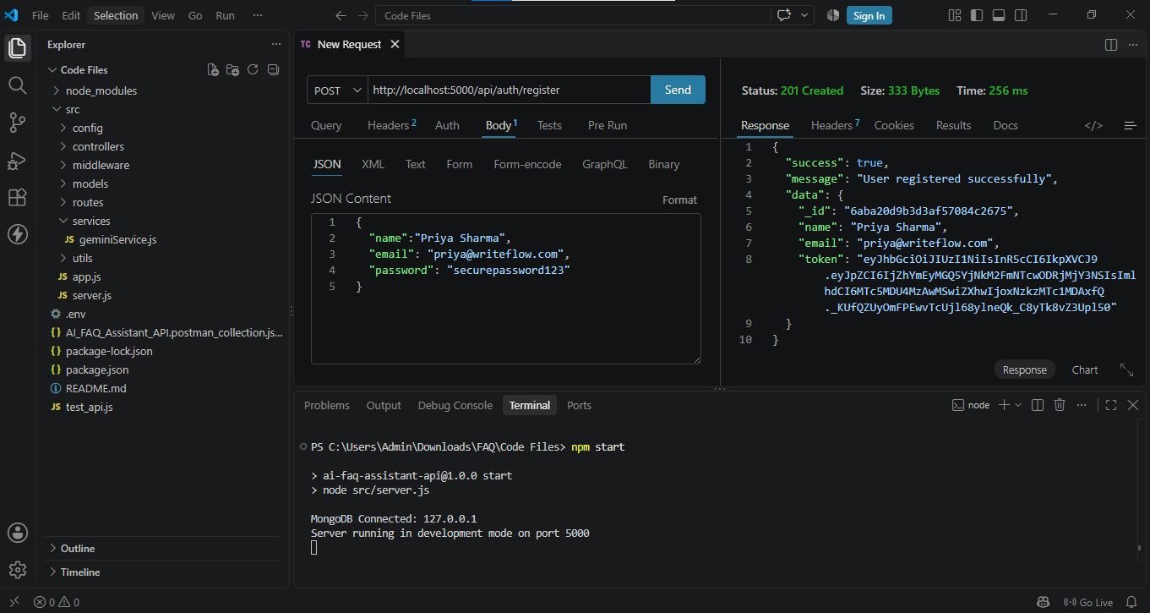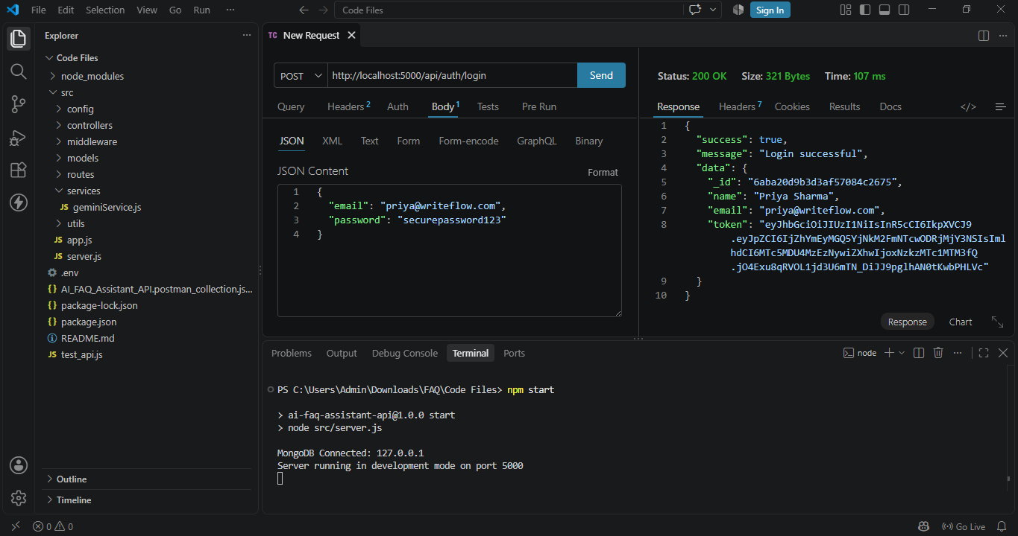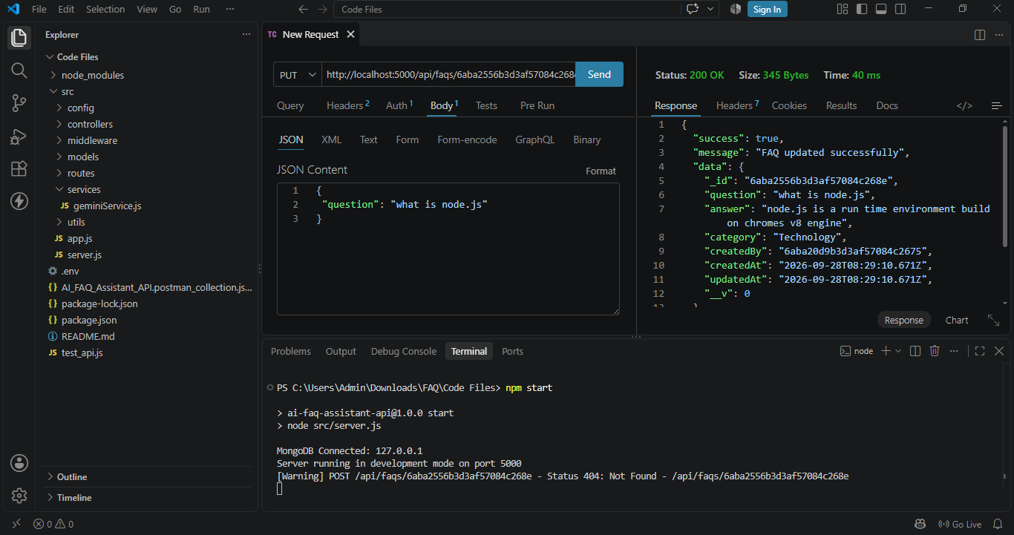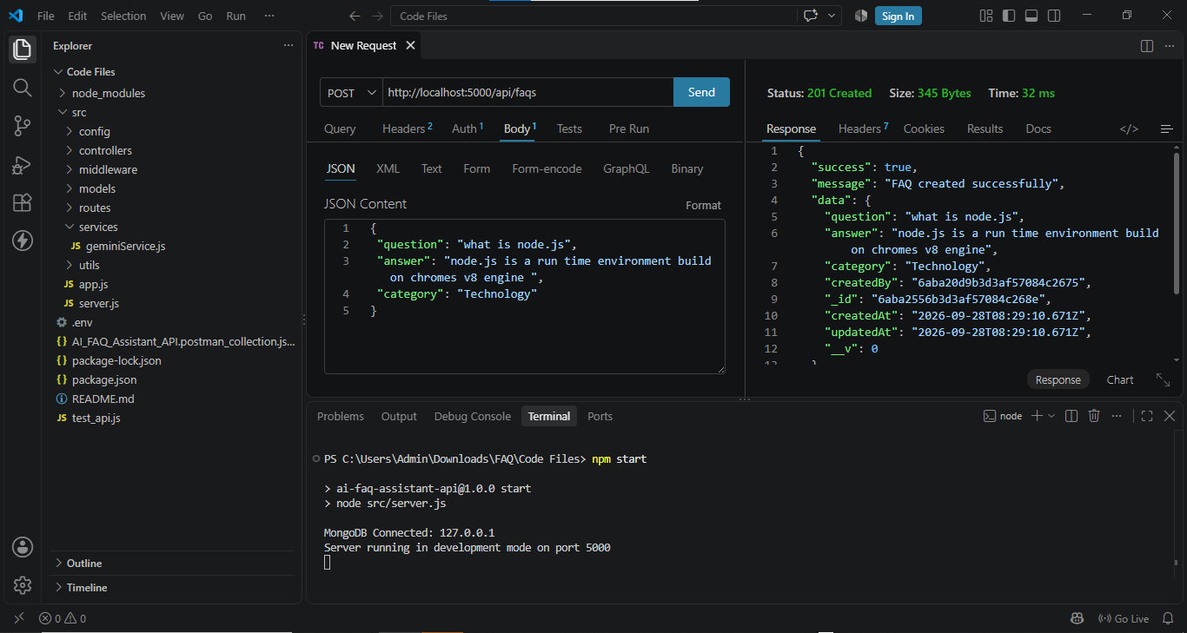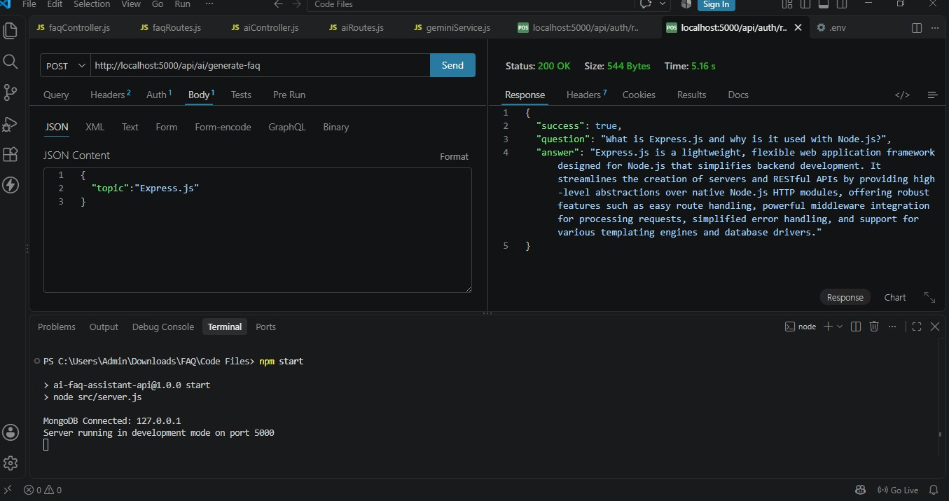

10.TESTING:
- Manual testing of the FAQ interface API testing using Postman
- Testing different user questions Testing FAQ search functionality
11.DEMO:

12.KNOWN ISSUES:
AI may not provide an answer when the question is outside the available FAQ data. Accuracy depends on the quality of the FAQ knowledge base.
Internet connection may be required for AI-based processing.

13.FUTURE ENHANCEMENT:
Voice-enabled FAQ Assistant Multilingual question answering Improved AI-based answer generation Voice input and speech recognition

